 | BETHLAHEM INSTITUTE OF ENGINEERING  NADUTHARI, KARUNGAL – 629 157  (Approved by AICTE,New Delhi 1-3361406901  &Affiliated to Anna University, Chennai)

CD3281
Data Structures and Algorithms Laboratory

(LABORATORY MANUAL)

(R-2021)

III SEMESTER

DEPARTMENT OF INFORMATION TECHNOLOGY

Prepared by:
HENILIN JK,AP/CSE

COLLEGE VISION
To become a premier institution and centre of professional education with moral ethics in engineering and technology to produce socio-friendly technocrats.

COLLEGE MISSION
• To provide quality skill-based professional education for all deserving candidates belonging to all sectors of society.
• To adopt innovative strategies, add-on courses, and establishes the state-of-the-art infrastructure for effective teaching learning processes and research activities.
• To attract and nurture the excellent and committed faculty members and the technicalworkforce.
• To organize healthy interactions with the stakeholders for the students’ overall personality development.
• To inculcate the social responsibilitiesamong the prospective engineers.
PROGRAM VISION
To provide highly recognized excellent technical education for Information Technology professionals with moral ethics.
PROGRAM MISSION
  - Providing quality technical education for the deserving candidates of all sectors of society.
  - Adopting innovative strategies and introducing add-on courses to face the global challenges in the field of information technology.
  - Encouraging the eminent and committed faculty members to keep themselves updated in the recent trends in information technology.
  - Establish the state-of-the-art computing system with advanced gadgets for effective teaching-learning process.
  - Arranging the platform to share the views of the stakeholders to improve the overall personality development of the students.
- Strengthening the social responsibilities of information technology professionals.

PROGRAM EDUCATIONAL OBJECTIVES (PEOs):
PEO1:Graduates will be able to demonstrate competence with analytical and critical thinking to understand and meet the diversified requirements of industry, academia and research.
PEO2:Graduates will be able to exhibit technical leadership, team skills and entrepreneurship skills to provide business solutions to real world problem.
PEO3: Graduates will be able to work in multi-disciplinary industries with social and environmental responsibility, work ethics and adaptability to address complex engineering and social problems.
PEO4:Graduates will be able to pursue lifelong learning, use cutting edge technologies and involve in applied research to design optimal solutions.
PROGRAMME OUTCOMES (POs)
Program outcomes
Engineering Graduates will be able to:
1. Engineering knowledge: Apply the knowledge of mathematics, science, engineering fundamentals, and an engineering specialization to the solution of complex engineering problems.
2. Problem analysis: Identify, formulate, review research literature, and analyze complex engineering problems reaching substantiated conclusions using first principles of mathematics, natural sciences, and engineering sciences.
3. Design/development of solutions: Design solutions for complex engineering problems and design system components or processes that meet the specified needs with appropriate consideration for the public health and safety, and the cultural, societal, and environmental considerations.
4. Conduct investigations of complex problems: Use research-based knowledge and research methods including design of experiments, analysis and interpretation of data, and synthesis of the information to provide valid conclusions.
5. Modern tool usage: Create, select, and apply appropriate techniques, resources, and modern engineering and IT tools including prediction and modeling to complex engineering activities with an understanding of the limitations.
6. The engineer and society: Apply reasoning informed by the contextual knowledge to assess societal, health, safety, legal and cultural issues and the consequent responsibilities relevant to the professional engineering practice.
7. Environment and sustainability: Understand the impact of the professional engineering solutions in societal and environmental contexts, and demonstrate the knowledge of, and need for sustainable development.
8. Ethics: Apply ethical principles and commit to professional ethics and responsibilities and norms of the engineering practice.
9. Individual and team work: Function effectively as an individual, and as a member or leader in diverse teams, and in multidisciplinary settings.
10. Communication: Communicate effectively on complex engineering activities with the engineering community and with society at large, such as, being able to comprehend and write effective reports and design documentation, make effective presentations, and give and receive clear instructions.
11. Project management and finance: Demonstrate knowledge and understanding of the engineering and management principles and apply these to one’s own work, as a member and leader in a team, to manage projects and in multidisciplinary environments.
12. Life-long learning: Recognize the need for, and have the preparation and ability to engage in independent and life-long learning in the broadest context of technological change.

PROGRAM SPECIFIC OBJECTIVES (PSOs)
PSO1: To design, develop and test IT application services with the help of different IT tools to solve complex engineering problems
PSO2: To enhance skill and adapt new programming skills with current research trends in computer technologies.

LABORATORY SAFETY RULES

Students should not involve in below mentioned activities in the lab
- Eating and drinking.
- Making a noise.
- Downloading data without authorization.
- Installing personal software on computers including games.
- Copy or transfer any software data.
- Plugging a personal USB/Card/CD or any other device into the computers.
- Interfering with or disturbing other students.
- Propagating computer viruses, spamming and offensive material.
- Tampering with, attempting to repair, or misusing the lab equipment.
- Bringing mobile phones and other multimedia devices.
- Writing on tables/computers.
- Viewing unwanted material, etc.
- Keeping sound levels to a minimum limit that doesn’t disturb others.

CD3281 & Data Structures and Algorithms Laboratory
Syllabus
Course Objectives
- To create ADTs in python

- To design and implement linear data structures such as list, stack and queue.

- To implement sorting, searching and hashing algorithm.

- To solve problems using tree and graph structures.

List of Experiments
1. Implement simple ADTs as Python classes
2. Implement recursive algorithms in Python
3. Implement List ADT using Python arrays
4. Linked list implementations of List
5. Implementation of Stack and Queue ADTs
6. Applications of List, Stack and Queue ADTs
7. Implementation of sorting and searching algorithms
8. Implementation of Hash tables
9. Tree representation and traversal algorithms
10. Implementation of Binary Search Trees
11. Implementation of Heaps Lab Manual
12. Graph representation and Traversal algorithms
13. Implementation of single source shortest path algorithm
14. Implementation of minimum spanning tree algorithms

Course Outcomes

CO1: Implement the concept of abstract data types .
CO2: Design, implement, and analyze linear data structures, such as lists, queues, and
stacks and its application
CO3: Design, implement, and analyze the searching, indexing, and sorting techniques
CO4: Design, implement, and analyze efficient tree structures.
CO5: Model the graph problems and implement the graph algorithms to resolve them

INDEX
Ex. No. | Name of the experiment | Page No.
1. | Adding two numbers using class
1. | Program to find the area of a rectangle using classes
2. | Python program to solve the Fibonacci sequence using recursion
2. | Python Program to Implement Binary Search with Recursion
3. | Implement the list ADT using dynamic array
4. | Python program to create a linked list and display its elements.
4. | program creates a doubly linked list
5. | Python Program to Implement Stack using Linked List
5. | Python Program to Implement Queue using Linked List
6. | Python Program to Check if Two Lists are Equal
6. | Python Program to Check String is Palindrome using Stack
7. | Python Program to Implement Linear Search
7. | Python Program to Perform Binary Search
7. | Python Program to Implement Bubble Sort
7. | Python Program to Implement Insertion Sort
7. | Python Program to Implement Selection Sort
8. | Implementation of Hash Tables
9. | Create Root and inserting into a tree
9. | Inorder Tree Traversal
9. | Preorder Tree Traversal
9. | Postorder Tree Traversal
10. | Implementation of Binary Search Tree
11 | Python Program to Implement Binary Heap
12 | Implementation of Depth First Traversal
12 | Python Program to Implement Breadth-First Search on a Graph
13 | Python Program to Implement Dijkstra’s Shortest Path Algorithm
14 | Python Program to Find Minimum Spanning Tree using Kruskal’s Algorithm

Ex.No.1 ADTs as Python Class

Aim:
To write a python program to implement the Abstract data types as python class.
Adding two numbers using class
Algorithm/Procedure:
1. Create a class and using a constructor to initialize values of that class.
2. Create methods for adding two numbers and print the respective results.
3. Take the two numbers as inputs and create an object for the class passing the two numbers as parameters to the class.
4. Using the object, call the respective function
6. Exit
Program:
class Add:
def __init__(self, a, b):
self.a = a
self.b = b
def sum(self):
print(f"The sum of {self.a} & {self.b} is {self.a+self.b}")
num1 = int(input("Enter first Number: "))
num2 = int(input("Enter Second Number: "))

num = Add(num1, num2)
num.sum()

Output:

Enter first Number:
2
Enter Second Number:
3
The sum of 2 & 3 is 5

Program to find the area of a rectangle using classes.

Procedure:

1. Take the value of length and breadth from the user.
2. Create a class and using a constructor initialises values of that class.
3. Create a method called as calculate_area and return the area of the class.
4. Create an object for the class.
5. Using the object, call the method calculate_area() with the parameters as the length and breadth taken from the user.
6. Print the area.
7. Exit

Program:
class shape_rectangle():
def __init__(self,my_length, my_breadth):
self.length = my_length
self.breadth = my_breadth
def calculate_area(self):
return self.length*self.breadth
a=int(input("Enter the length of the rectangle : "))
b=int(input("Enter the breadth of the rectangle : "))
my_instance = shape_rectangle(a,b)
print("The area of the rectangle : ",my_instance.calculate_area())

Output:
Enter the length of the rectangle :
6
Enter the breadth of the rectangle :
45
The area of the rectangle :
270

Result:
Thus the implementation of Abstract data types as python classes is executed successfully.

Ex.No:2 Recursive Algorithm in python

Aim:
To write a python program to implement the Recursive algorithm in python.

Python program to solve the Fibonacci sequence using recursion

Procedure:

1.Define function factorial() to calculate factorial
2. Check if the entered number is 1 or 0, if true return the number
3. If false, call the function recursively to calculate factorial of the number minus 1
4. Return the value of the number multiplied by the factorial of the number minus 1
5.Print the result
Program:

def factorial(n):
if (n==1 or n==0):
return 1
else:
return n * factorial(n - 1)

num = int(input("Enter number: "))
x=factorial(num)
print("Factorial of",num,"is",x)

Output:

Enter number: 5
Factorial of 5 is 120

Python Program to Implement Binary Search with Recursion

Procedure:
1.A function named 'binary_search' is defined.
2.It takes the list, the 'low' variable, 'high' variable and the element to be searched as parameter.
3.Then, the variable 'mid' is assigned the average of 'high' and 'low' variables.
4.If the element at 'mid' is same as the element that needs to be searched for, it is returned.
5.Else, if the element at 'mid' position is greater than the element to be searched, the function is called again by passing different set of parameters.
6.Else if the element at 'mid' position is less than the element to be searched, the function is called again by passing a different set of parameters.
7.Now the list is defined, and the function is called by passing this list as parameter.
8.This operation's data is stored in a variable.
9.This variable is the output that is displayed on the console.

Program:
def binary_search(my_list, low, high, elem):
if high >= low:
mid = (high + low) // 2
if my_list[mid] == elem:
return mid
elif my_list[mid] > elem:
return binary_search(my_list, low, mid - 1, elem)
else:
return binary_search(my_list, mid + 1, high, elem)
else:
return -1
my_list = [ 1, 9, 11, 21, 34, 54, 67, 90 ]
elem_to_search = 1
print("The list is")
print(my_list)
my_result = binary_search(my_list,0,len(my_list)-1,elem_to_search)
if my_result != -1:
print("Element found at index ", str(my_result))
else:
print("Element not found!")

Output:
The list is
[1, 9, 11, 21, 34, 54, 67, 90]
Element found at index 0

Result:
Thus the implementation of recursive algorithm in python is executed successfully

Ex.No.3 List ADT Using Python Arrays

Aim:
To write a python program to implement the list ADT using python arrays.

Procedure :

- Allocate a new array B with larger capacity
- Set B[i]=A[i], for i=0 to n-1 where n denotes the current no of items.
- Set A=B that is, we hence forth use B as the array of supporting list.
- Insert new element in the new array.
- Get the length of the array
- Access an element in the array.
- Append a new element to the array
- Pop the element from the end of the array

Program:
import ctypes

class DynamicArray(object):
def __init__(self):
self.n = 0
self.size = 1
self.A = self.make_array(self.size)

def __len__(self):
return self.n

def add(self, ele):
if self.n == self.size:
self._reshape(2 * self.size)
self.A[self.n] = ele
self.n += 1

def remove(self):
if self.n == 0:
print("Array is empty, Please add an element first.")
return
self.A[self.n-1] = 0
self.n -= 1

def appendAt(self, item, ind):
if ind < 0 or ind > self.n:
print("Please enter with the range of the index !")
return
if self.n == self.size:
self._reshape(2*self.size)
for i in range(self.n-1, ind-1, -1):
self.A[i+1] = self.A[i]
self.A[ind] = item
self.n += 1

def deleteAt(self, ind):
if self.n == 0:
print("Array is empty, Please add an element first !!")
return
if ind < 0 or ind >= self.n:
return indError("The index is not within the range, Deletion is not possible.")
if ind == self.n-1:
self.A[ind] = 0
self.n -= 1
return
for i in range(ind, self.n-1):
self.A[i] = self.A[i+1]
self.A[self.n-1] = 0
self.n -= 1

def __getiele__(self, k):
if not 0 <= k < self.n:
return ('k is out of bounds !')

return self.A[k]

def _reshape(self, new_size):
B = self.make_array(new_size)
for k in range(self.n):
B[k] = self.A[k]
self.A = B
self.size = new_size

def make_array(self, new_size):
return (new_size * ctypes.py_object)()

arr = DynamicArray()
arr.add(1)
arr.add(23)
arr.appendAt(25,2)
arr.add(12)
arr.add(34)
print(arr)

print(arr.__len__())
print(arr.__getiele__(1))

arr.remove()
print(arr)

print(arr.__getiele__(3))
print(arr.__len__())

arr.add(10)
arr.add(70)
print(arr)

print(arr.__len__())

arr.deleteAt(1)
print(arr)

print(arr.__getiele__(2))
print(arr.__len__())

Output:

[1,23,25,12,34]

5

23

[1,23,25,12]

12

4

[1,23,25,12,10,70]

6

[1,25,12,10,70]

12

5

Result:
Thus the implementation of list ADT using python array is executed successfully

Ex.No.4 Implementation of Linked List

Aim:
To write a python program to implement the linked list using python

Python program to create a linked list and display its elements.

Procedure:

- Create a class Node with instance variables data and next.
- Create a class Linked List with instance variables head and last_node.
- The variable head points to the first element in the linked list while last_node points to the last.
- Define methods append and display inside the class Linked List to append data and display the linked list respectively.
- Create an instance of Linked List, append data to it and display the list.

Program:

class Node:
def __init__(self, data):
self.data = data
self.next = None

class LinkedList:
def __init__(self):
self.head = None
self.last_node = None

def append(self, data):
if self.last_node is None:
self.head = Node(data)
self.last_node = self.head
else:
self.last_node.next = Node(data)
self.last_node = self.last_node.next

def display(self):
current = self.head
while current is not None:
print(current.data, end = ' ')
current = current.next

a_llist = LinkedList()
n = int(input('How many elements would you like to add? '))
for i in range(n):
data = int(input('Enter data item: '))
a_llist.append(data)
print('The linked list: ', end = ' ' )
a_llist.display()

Output:

How many elements would you like to add? 5
Enter data item: 3
Enter data item: -2
Enter data item: 1
Enter data item: 5
Enter data item: 0
The linked list: 3 -2 1 5 0

program creates a doubly linked list and presents the user with a menu to perform various operations on the list.

Procedure:
1.Create a class Node with instance variables data and next.
2. Create a class DoublyLinkedList with instance variables first and last.
3. The variable first points to the first element in the doubly linked list while last points to the last element.
4. Define methods get_node, insert_after, insert_before, insert_at_beg, insert_at_end, remove and display.
5. get_node takes an index as argument and traverses the list from the first node that many times to return the node at that index.
6. The methods insert_after and insert_before insert a node after or before some reference node in the list.
7. The methods insert_at_beg and insert_at_end insert a node at the first or last position of the list.
8. The method remove takes a node as argument and removes it from the list.
9. The method display traverses the list from the first node and prints the data of each node.
10. Create an instance of DoublyLinkedList and present the user with a menu to perform operations on the list.

Program:

class Node:
def __init__(self, data):
self.data = data
self.next = None
self.prev = None

class DoublyLinkedList:
def __init__(self):
self.first = None
self.last = None

def get_node(self, index):
current = self.first
for i in range(index):
if current is None:
return None
current = current.next
return current

def insert_after(self, ref_node, new_node):
new_node.prev = ref_node
if ref_node.next is None:
self.last = new_node
else:
new_node.next = ref_node.next
new_node.next.prev = new_node
ref_node.next = new_node

def insert_before(self, ref_node, new_node):
new_node.next = ref_node
if ref_node.prev is None:
self.first = new_node
else:
new_node.prev = ref_node.prev
new_node.prev.next = new_node
ref_node.prev = new_node

def insert_at_beg(self, new_node):
if self.first is None:
self.first = new_node
self.last = new_node
else:
self.insert_before(self.first, new_node)

def insert_at_end(self, new_node):
if self.last is None:
self.last = new_node
self.first = new_node
else:
self.insert_after(self.last, new_node)

def remove(self, node):
if node.prev is None:
self.first = node.next
else:
node.prev.next = node.next

if node.next is None:
self.last = node.prev
else:
node.next.prev = node.prev

def display(self):
current = self.first
while current:
print(current.data, end = ' ')
current = current.next

a_dllist = DoublyLinkedList()

print('Menu')
print('insert <data> after <index>')
print('insert <data> before <index>')
print('insert <data> at beg')
print('insert <data> at end')
print('remove <index>')
print('quit')

while True:
print('The list: ', end = '')
a_dllist.display()
print()
do = input('What would you like to do? ').split()

operation = do[0].strip().lower()

if operation == 'insert':
data = int(do[1])
position = do[3].strip().lower()
new_node = Node(data)
suboperation = do[2].strip().lower()
if suboperation == 'at':
if position == 'beg':
a_dllist.insert_at_beg(new_node)
elif position == 'end':
a_dllist.insert_at_end(new_node)
else:
index = int(position)
ref_node = a_dllist.get_node(index)
if ref_node is None:
print('No such index.')
continue
if suboperation == 'after':
a_dllist.insert_after(ref_node, new_node)
elif suboperation == 'before':
a_dllist.insert_before(ref_node, new_node)

elif operation == 'remove':
index = int(do[1])
node = a_dllist.get_node(index)
if node is None:
print('No such index.')
continue
a_dllist.remove(node)

elif operation == 'quit':
break

Output:
Case 1:
Menu
insert <data> after <index>
insert <data> before <index>
insert <data> at beg
insert <data> at end
remove <index>
quit
The list:
What would you like to do? insert 5 at beg
The list: 5
What would you like to do? insert 3 at beg
The list: 3 5
What would you like to do? insert 1 at end
The list: 3 5 1
What would you like to do? insert 10 after 1
The list: 3 5 10 1
What would you like to do? insert 0 before 2
The list: 3 5 0 10 1
What would you like to do? remove 4
The list: 3 5 0 10
What would you like to do? remove 1
The list: 3 0 10
What would you like to do? remove 5
No such index.
The list: 3 0 10
What would you like to do? quit

Case 2:
Menu
insert <data> after <index>
insert <data> before <index>
insert <data> at beg
insert <data> at end
remove <index>
quit
The list:
What would you like to do? insert 3 after 0
No such index.
The list:
What would you like to do? insert 2 at beg
The list: 2
What would you like to do? insert 3 before 0
The list: 3 2
What would you like to do? remove 0
The list: 2
What would you like to do? remove 0
The list:
What would you like to do? quit

Result:
Thus the implementation of linked list using python is executed successfully

Ex.No.5 Implementation of Stack and Queue ADTs
Aim:
To write a python program to implement the Stack and Queue ADTs

Python Program to Implement Stack using Linked List

Procedure:
1.Create a class Node with instance variables data and next.
2. Create a class Stack with instance variable head.
3. The variable head points to the first element in the linked list.
4. Define methods push and pop inside the class Stack.
5. The method push adds a node at the front of the linked list.
6. The method pop returns the data of the node at the front of the linked list and removes the node. It returns None if there are no nodes.
7. Create an instance of Stack and present a menu to the user to perform operations on the stack.
Program:
class Node:
def init (self,data):
self.data=data
self.next=None
class Stack:
def init (self):
self.head=None
self.ctr=0
self.top=None
def Push(self,data):
node=Node(data)
if self.head==None:
self.head=node
self.top=node
else:
self.top.next=node
self.top=node
print("Node pushed to stack",data)
self.ctr+=1
return
def Pop(self):
if self.head==None:
print("Stack Underflow")
elif self.head==self.top:
print("Deleted from Stack",self.head.data)
self.head=self.top=None
self.ctr-=1
else:
print("Deleted from Stack",self.top.data)
temp=self.head
while temp.next is not self.top:
temp=temp.next
temp.next=None
self.top=temp
self.ctr-=1
return
def Traverse(self):
if self.head==None:
print("No Nodes exist")
return
temp=self.head
while temp is not None:
print(temp.data)
temp=temp.next
def Menu():
print("1.Push\n2.Pop\n3.Traverse\n4.Number of nodes\n5.Exit")
ch=int(input("Enter choice:"))
return ch
s=Stack()
print("**************Stack*****************")
while True:
ch=Menu()
if ch==1:
data=input("Enter data:")
s.Push(data)
elif ch==2:
s.Pop()
elif ch==3:
s.Traverse()
elif ch==4:
print("Number of nodes",s.ctr)
else:
print('Quit')
break

Output:
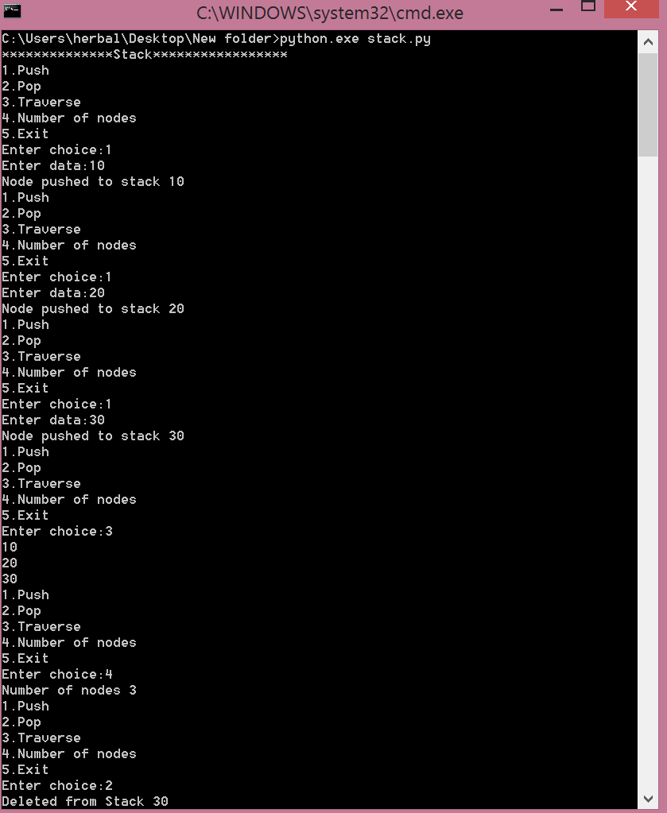

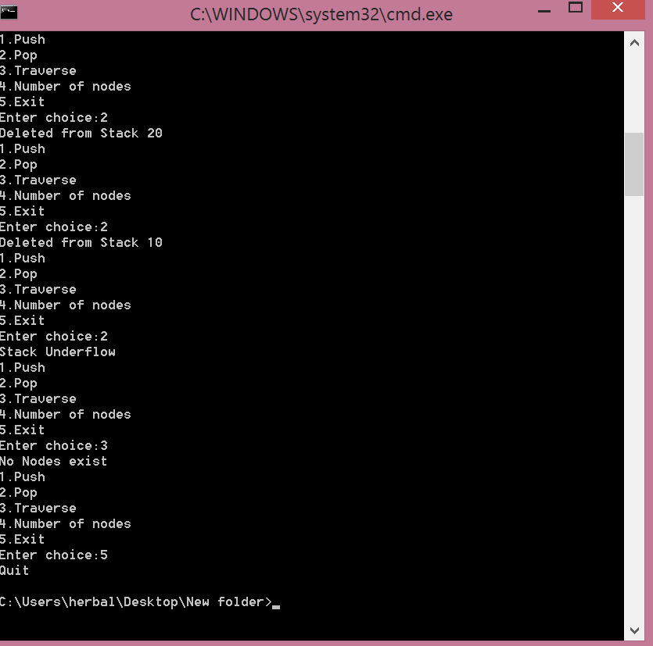

Python Program to Implement Queue using Linked List

Procedure:
1.Create a class Node with instance variables data and next.
2. Create a class Queue with instance variables head and last.
3. The variable head points to the first element in the linked list while last points to the last element.
4. Define methods enqueue and dequeue inside the class Queue.
5. The method enqueue adds a node at the end of the linked list.
6. The method dequeue returns the data of the node at the front of the linked list and removes the node. It returns None if there are no nodes.
7. Create an instance of Queue and present a menu to the user to perform operations on the queue.
Program:
class Node:
def init (self,data):
self.data=data
self.next=None

class Queue:
def init (self):
self.front=None
self.ctr=0
self.rear=None
def Enqueue(self,data):
node=Node(data)
if self.front==None:
self.front=node
self.rear=node
else:
self.rear.next=node
self.rear=node
print("Node enqueued to queue",data)
self.ctr+=1
return
def Dequeue(self):
if self.front==None:
print("No Nodes exist")
else:
print("Dequeued from queue",self.front.data)
self.front=self.front.next
self.ctr-=1
return
def Traverse(self):
if self.front==None:
print("No Nodes exist")
return
temp=self.front
while temp is not None:
print(temp.data)
temp=temp.next

def Menu():
print("1.Enqueue\n2.Dequeue\n3.Traverse\n4.Number of nodes\n5.Exit")
ch=int(input("Enter choice:"))
return ch
print("*******************Queue*************")
s=Queue()
while True:
ch=Menu()
if ch==1:
data=input("Enter data:")
s.Enqueue(data)
elif ch==2:
s.Dequeue()
elif ch==3:
s.Traverse()
elif ch==4:
print("Number of nodes",s.ctr)
else:
print('Quit')
break
Output:

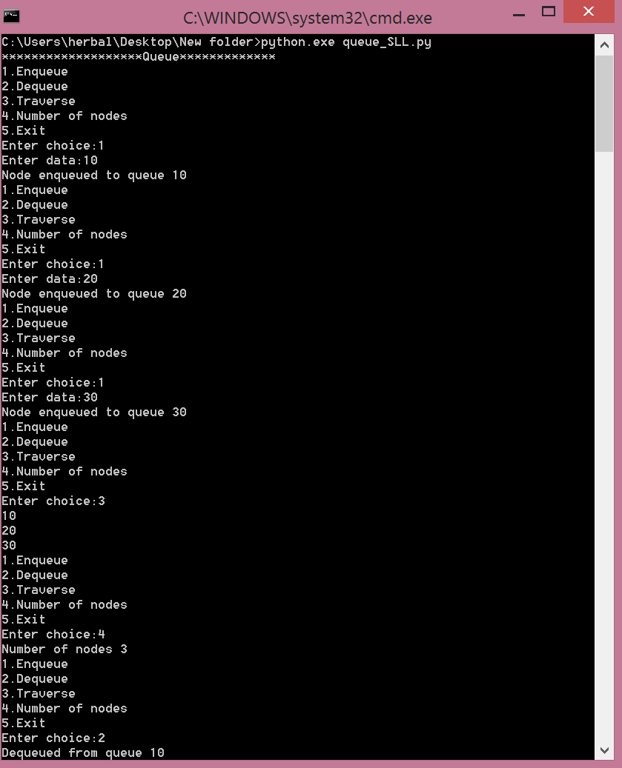
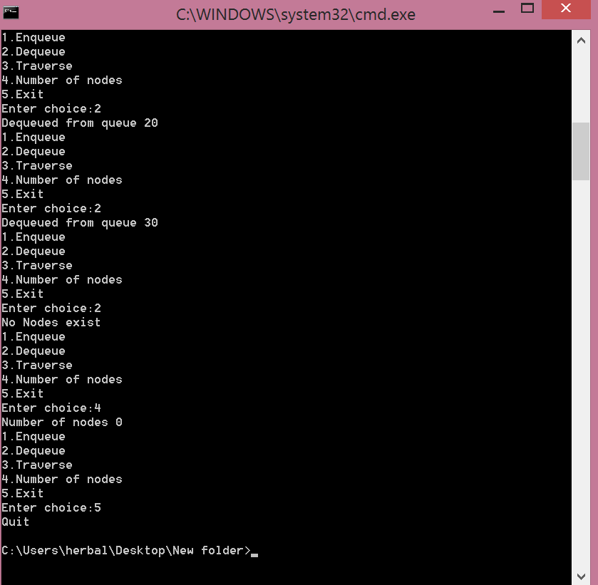
Result:
Thus the implementation of stack and queue ADTS using python is executed successfully
Ex.No.6 Application of List,Stack and Queue ADTs
Aim:
To write a python program to implement the Stack and Queue ADTs

Python Program to Check if Two Lists are Equal
Procedure:
1.Create a class Node with instance variables data and next.
2. Create a class LinkedList with instance variables head and last_node.
3. The variable head points to the first element in the linked list while last_node points to the last.
4. Define methods append and display inside the class LinkedList to append data and display the linked list respectively.
5. Define a function is_equal which takes two linked lists as arguments.
6. The function is_equal returns True only if the two linked lists are of the same length and contain the same data items.
7. Create two instances of LinkedList and append data to it.
8. Check whether they are the same.
Program:
class Node:
def __init__(self, data):
self.data = data
self.next = None

class LinkedList:
def __init__(self):
self.head = None
self.last_node = None

def append(self, data):
if self.last_node is None:
self.head = Node(data)
self.last_node = self.head
else:
self.last_node.next = Node(data)
self.last_node = self.last_node.next

def is_equal(llist1, llist2):
current1 = llist1.head
current2 = llist2.head
while (current1 and current2):
if current1.data != current2.data:
return False
current1 = current1.next
current2 = current2.next
if current1 is None and current2 is None:
return True
else:
return False

llist1 = LinkedList()
llist2 = LinkedList()

data_list = input('Please enter the elements in the first linked list: ').split()
for data in data_list:
llist1.append(int(data))

data_list = input('Please enter the elements in the second linked list: ').split()
for data in data_list:
llist2.append(int(data))

if is_equal(llist1, llist2):
print('The two linked lists are the same.')
else:
print('The two linked list are not the same.', end = '')

Output:
Case 1:
Please enter the elements in the first linked list: 5 8 10 12
Please enter the elements in the second linked list: 5 8 10 12
The two linked lists are the same.

Case 2:
Please enter the elements in the first linked list: 12 3 4 5 0
Please enter the elements in the second linked list: 12 3
The two linked list are not the same.

Case 3:
Please enter the elements in the first linked list: 4 1
Please enter the elements in the second linked list: 2 19 4
The two linked list are not the same.

Python Program to Check String is Palindrome using Stack
Procedure:
Create a class Stack with instance variable items initialized to an empty list.
2. Define methods push, pop and is_empty inside the class Stack.
3. The method push appends data to items.
4. The method pop pops the first element in items.
5. The method is_empty returns True only if items is empty.
6. Prompt the user for a string and push all the characters to a stack.
7. Construct the reversed string by popping characters from the stack.
8. Deterime whether the string is palindromic by comparing the two strings.
Program:
class Stack:
def __init__(self):
self.items = []

def is_empty(self):
return self.items == []

def push(self, data):
self.items.append(data)

def pop(self):
return self.items.pop()

s = Stack()
text = input('Please enter the string: ')

for character in text:
s.push(character)

reversed_text = ''
while not s.is_empty():
reversed_text = reversed_text + s.pop()

if text == reversed_text:
print('The string is a palindrome.')
else:
print('The string is not a palindrome.')

Output:
Case 1:
Please enter the string: madam
The string is a palindrome.

Case 2:
Please enter the string: racecar
The string is a palindrome.

Case 3:
Please enter the string: palace
The string is not a palindrome.

Result:
Thus the implementation of list stack and queue ADTS using python is executed successfully

Ex.No.7 Implementation of sorting and searching algorithm
Aim:
To write a python program to implement the sorting and searching algorithm

Python Program to Implement Linear Search
Procedure:
1. Create a function linear_search that takes a list and key as arguemnts.
2. A loop iterates through the list and when an item matching the key is found, the corresponding index is returned.
3. If no such item is found, -1 is returned.
Program:
def linear_search(alist, key):
"""Return index of key in alist. Return -1 if key not present."""
for i in range(len(alist)):
if alist[i] == key:
return i
return -1

alist = input('Enter the list of numbers: ')
alist = alist.split()
alist = [int(x) for x in alist]
key = int(input('The number to search for: '))

index = linear_search(alist, key)
if index < 0:
print('{} was not found.'.format(key))
else:
print('{} was found at index {}.'.format(key, index))

Output:
Case 1:
Enter the list of numbers: 5 4 3 2 1 10 11 2
The number to search for: 1
1 was found at index 4.

Case 2:
Enter the list of numbers: 5 2 1 5 -3
The number to search for: 2
2 was found at index 1.

Case 3:
Enter the list of numbers: 3 5 6
The number to search for: 2
2 was not found.

Python Program to Perform Binary Search
Procedure:
1. Create a function binary_search that takes a list and key as arguments.
2. The variable start is set to 0 and end is set to the length of the list.
3. The variable start keeps track of the first element in the part of the list being searched while end keeps track of the element one after the end of the part being searched.
4. A while loop is created that iterates as long as start is less than end.
5. mid is calculated as the floor of the average of start and end.
6. If the element at index mid is less than key, start is set to mid + 1 and if it is more than key, end is set to mid. Otherwise, mid is returned as the index of the found element.
7. If no such item is found, -1 is returned.
Program:
def binary_search(alist, key):
"""Search key in alist[start... end - 1]."""
start = 0
end = len(alist)
while start < end:
mid = (start + end)//2
if alist[mid] > key:
end = mid
elif alist[mid] < key:
start = mid + 1
else:
return mid
return -1

alist = input('Enter the sorted list of numbers: ')
alist = alist.split()
alist = [int(x) for x in alist]
key = int(input('The number to search for: '))

index = binary_search(alist, key)
if index < 0:
print('{} was not found.'.format(key))
else:
print('{} was found at index {}.'.format(key, index))

Output:
Case 1:
Enter the sorted list of numbers: 3 5 10 12 15 20
The number to search for: 12
12 was found at index 3.

Case 2:
Enter the sorted list of numbers: -3 0 1 5 6 7 8
The number to search for: 2
2 was not found.

Case 3:
Enter the sorted list of numbers: 5
The number to search for: 5
5 was found at index 0.

Python Program to Implement Bubble Sort
Procedure:
1. Create a function bubble_sort that takes a list as argument.
2. Inside the function create a loop with a loop variable i that counts from the length of the list – 1 to 1.
3. Create an inner loop with a loop variable that counts from 0 up to i – 1.
4. Inside the inner loop, if the elements at indexes j and j + 1 are out of order, then swap them.
5. If in one iteration of the inner loop there were no swaps, then the list is sorted and one can return prematurely.
Program:
def bubble_sort(alist):
for i in range(len(alist) - 1, 0, -1):
no_swap = True
for j in range(0, i):
if alist[j + 1] < alist[j]:
alist[j], alist[j + 1] = alist[j + 1], alist[j]
no_swap = False
if no_swap:
return

alist = input('Enter the list of numbers: ').split()
alist = [int(x) for x in alist]
bubble_sort(alist)
print('Sorted list: ', end='')
print(alist)

Output:
Case 1:
Enter the list of numbers: 4 2 38 10 5
Sorted list: [2, 4, 5, 10, 38]

Case 2:
Enter the list of numbers: 5 4 3 2 1
Sorted list: [1, 2, 3, 4, 5]

Case 3:
Enter the list of numbers: 7 3 1 -5 2 10
Sorted list: [-5, 1, 2, 3, 7, 10]

Python Program to Implement Insertion Sort
Procedure:
1. Create a function insertion_sort that takes a list as argument.
2. Inside the function create a loop with a loop variable i that counts from 1 to the length of the list – 1.
3. Set temp equal to the element at index i.
4. Set j equal to i – 1.
5. Create a while loop that runs as long as j is non-negative and temp is smaller than the element at index j.
6. Inside the while loop, set the element at index j + 1 equal to the element at index j and decrement j.
7. After the while loop finishes, set the element at index j + 1 equal to temp.
Program:
def insertion_sort(alist):
for i in range(1, len(alist)):
temp = alist[i]
j = i - 1
while (j >= 0 and temp < alist[j]):
alist[j + 1] = alist[j]
j = j - 1
alist[j + 1] = temp

alist = input('Enter the list of numbers: ').split()
alist = [int(x) for x in alist]
insertion_sort(alist)
print('Sorted list: ', end='')
print(alist)

Output:
Case 1:
Enter the list of numbers: 2 4 1 5 8 0
Sorted list: [0, 1, 2, 4, 5, 8]

Case 2:
Enter the list of numbers: 5 4 3 2 0 -1
Sorted list: [-1, 0, 2, 3, 4, 5]

Case 3:
Enter the list of numbers: 3 4 1 4 5 0 7
Sorted list: [0, 1, 3, 4, 4, 5, 7]

Python Program to Implement Selection Sort
Procedure:
1. Create a function selection_sort that takes a list as argument.
2. Inside the function create a loop with a loop variable i that counts from 0 to the length of the list – 1.
3. Create a variable smallest with initial value i.
4. Create an inner loop with a loop variable j that counts from i + 1 up to the length of the list – 1.
5. Inside the inner loop, if the elements at index j is smaller than the element at index smallest, then set smallest equal to j.
6. After the inner loop finishes, swap the elements at indexes i and smallest.
Program:
def selection_sort(alist):
for i in range(0, len(alist) - 1):
smallest = i
for j in range(i + 1, len(alist)):
if alist[j] < alist[smallest]:
smallest = j
alist[i], alist[smallest] = alist[smallest], alist[i]

alist = input('Enter the list of numbers: ').split()
alist = [int(x) for x in alist]
selection_sort(alist)
print('Sorted list: ', end='')
print(alist)

Output:
Case 1:
Enter the list of numbers: 3 1 4 5 2 6
Sorted list: [1, 2, 3, 4, 5, 6]

Case 2:
Enter the list of numbers: 2 10 5 38 1 7
Sorted list: [1, 2, 5, 7, 10, 38]

Case 3:
Enter the list of numbers: 5 3 2 1 0
Sorted list: [0, 1, 2, 3, 5]

Result:
Thus the implementation of sorting and searching algorithms using python is executed successfully

Ex.No.8 Implementation of Hash Tables
Aim:
To write a python program to implement the hash tables
Procedure:
- Defines a function hash_key that accepts the parameters key and m.
- Uses a simple modulus operation to determine the hash value
- Defines a variable m that is initialized to the value 7. This is the size of our hash table
- Calculates and prints the hash value of 3
- Calculates and prints the hash value of 2
- Calculates and prints the hash value of 9
- Calculates and prints the hash value of 11
- Calculates and prints the hash value of 7
Program:
def hash_key( key, m):
return key % m

m = 7

print(f'The hash value for 3 is {hash_key(3,m)}')
print(f'The hash value for 2 is {hash_key(2,m)}')
print(f'The hash value for 9 is {hash_key(9,m)}')
print(f'The hash value for 11 is {hash_key(11,m)}')
print(f'The hash value for 7 is {hash_key(7,m)}')

Output:
The hash value for 3 is 3
The hash value for 2 is 2
The hash value for 9 is 2
The hash value for 11 is 4
The hash value for 7 is 0

Result:
Thus the implementation of hash tables using python is executed successfully

Ex.No.9 Implementation of tree representation and traversal algorithms
Aim:
To write a python program to implement the tree representation and traversal algorithms
Procedure:

Create Root
1.Create a Node class and add assign a value to the node.
2.Now the tree with only a root node is created.
Program:
class Node:
def __init__(self, data):
self.left = None
self.right = None
self.data = data
def PrintTree(self):
print(self.data)

root = Node(10)
root.PrintTree()
Output:
10

Inserting into a Tree
1.To insert into a tree we use the same node class created above and add a insert class to it.
2.The insert class compares the value of the node to the parent node and decides to add it as a left node or a right node.
3. Finally the PrintTree class is used to print the tree.
Program:
class Node:
def __init__(self, data):
self.left = None
self.right = None
self.data = data

def insert(self, data):
# Compare the new value with the parent node
if self.data:
if data < self.data:
if self.left is None:
self.left = Node(data)
else:
self.left.insert(data)
elif data > self.data:
if self.right is None:
self.right = Node(data)
else:
self.right.insert(data)
else:
self.data = data

# Print the tree
def PrintTree(self):
if self.left:
self.left.PrintTree()
print( self.data),
if self.right:
self.right.PrintTree()

# Use the insert method to add nodes
root = Node(12)
root.insert(6)
root.insert(14)
root.insert(3)
root.PrintTree()

Output:
3 6 12 14

Inorder Tree Traversal
Procedure:
1.First visit the left subtree of the original tree.
2.Then we will traverse the root node of the tree
3. Lastly the right subtree of the original tree.
Program :
class TreeNode:
def __init__(self, val):
self.val = val
self.left = None
self.right = None

def inorderTraversal(root):
answer = []

inorderTraversalUtil(root, answer)
return answer

def inorderTraversalUtil(root, answer):

if root is None:
return

inorderTraversalUtil(root.left, answer)
answer.append(root.val)
inorderTraversalUtil(root.right, answer)
return

root = TreeNode(1)
root.left = TreeNode(2)
root.right = TreeNode(3)
root.left.left = TreeNode(4)
root.left.right = TreeNode(5)

print(inorderTraversal(root))

Output:
[4,2,5,1,3]

Preorder Tree Traversal
Procedure:
1.First visit the root of the original tree.
2.Then we will traverse the left subtree of the original tree
3. Lastly the right subtree of the original tree.
Program:
class TreeNode:

def __init__(self,val):
self.val = val
self.left = None
self.right = None

def preorderTraversal(root):
answer = []

preorderTraversalUtil(root, answer)
return answer

def preorderTraversalUtil(root, answer):

if root is None:
return

answer.append(root.val)

preorderTraversalUtil(root.left, answer)

preorderTraversalUtil(root.right, answer)

return

root = TreeNode(1)
root.left = TreeNode(2)
root.right = TreeNode(3)
root.left.left = TreeNode(4)
root.left.right = TreeNode(5)

print(preorderTraversal(root))

Output:
[1,2,4,5,3]

Postorder Tree Traversal
Procedure:
1.First visit the left subtree of the original tree followed by the right subtree .
2. Lastly the root node of the original tree.
Program:
class TreeNode:

def __init__(self, val):
self.val = val
self.left = None
self.right = None

def postorderTraversal(root):
answer = []

postorderTraversalUtil(root, answer)
return answer

def postorderTraversalUtil(root, answer):

if root is None:
return

postorderTraversalUtil(root.left, answer)

postorderTraversalUtil(root.right, answer)

answer.append(root.val)

return

root = TreeNode(1)
root.left = TreeNode(2)
root.right = TreeNode(3)
root.left.left = TreeNode(4)
root.left.right = TreeNode(5)

print(postorderTraversal(root))

Output:
[4,5,3,2,1]

Result:
Thus the implementation of tree representation and traversal algorithms using python is executed successfully

Ex.No.10 Implementation of Binary Search Tree
Aim:
To write a python program to implement the binary search tree.
Procedure:
1.Initially create new node and declare it as root.
2.While inserting a new node, if the value of the new data is less than the value of the current node, we will add it to the left child of the binary search tree, otherwise, we will add it to the right child.
Program:
class BinaryTreeNode:
def __init__(self, data):
self.data = data
self.leftChild = None
self.rightChild=None

def insert(root,newValue):
#if binary search tree is empty, make a new node and declare it as root
if root is None:
root=BinaryTreeNode(newValue)
return root
#binary search tree is not empty, so we will insert it into the tree
#if newValue is less than value of data in root, add it to left subtree and proceed recursively
if newValue<root.data:
root.leftChild=insert(root.leftChild,newValue)
else:
#if newValue is greater than value of data in root, add it to right subtree and proceed recursively
root.rightChild=insert(root.rightChild,newValue)
return root

root= insert(None,15)
insert(root,10)
insert(root,25)
insert(root,6)
insert(root,14)
insert(root,20)
insert(root,60)
a1=root
a2=a1.leftChild
a3=a1.rightChild
a4=a2.leftChild
a5=a2.rightChild
a6=a3.leftChild
a7=a3.rightChild
print("Root Node is:")
print(a1.data)
print("left child of node is:")
print(a1.leftChild.data)
print("right child of node is:")
print(a1.rightChild.data)
print("Node is:")
print(a2.data)
print("left child of node is:")
print(a2.leftChild.data)
print("right child of node is:")
print(a2.rightChild.data)
print("Node is:")
print(a3.data)
print("left child of node is:")
print(a3.leftChild.data)
print("right child of node is:")
print(a3.rightChild.data)
print("Node is:")
print(a4.data)
print("left child of node is:")
print(a4.leftChild)
print("right child of node is:")
print(a4.rightChild)
print("Node is:")
print(a5.data)
print("left child of node is:")
print(a5.leftChild)
print("right child of node is:")
print(a5.rightChild)
print("Node is:")
print(a6.data)
print("left child of node is:")
print(a6.leftChild)
print("right child of node is:")
print(a6.rightChild)
print("Node is:")
print(a7.data)
print("left child of node is:")
print(a7.leftChild)
print("right child of node is:")
print(a7.rightChild)

Output:
Root Node is:
15
left child of node is:
10
right child of node is:
25
Node is:
10
left child of node is:
6
right child of node is:
14
Node is:
25
left child of node is:
20
right child of node is:
60
Node is:
6
left child of node is:
None
right child of node is:
None
Node is:
14
left child of node is:
None
right child of node is:
None
Node is:
20
left child of node is:
None
right child of node is:
None
Node is:
60
left child of node is:
None
right child of node is:
None

Result:
Thus the implementation of binary search tree using python is executed successfully

Ex.No.11 Implementation of Heaps
Aim:
To write a python program to implement the heap.

Python Program to Implement Binary Heap
Procedure:
1. Create a class BinaryHeap with an instance variable items set to an empty list. This empty list is used to store the binary heap.
2. Define methods size, parent, left, right, get, get_max, extract_max, max_heapify, swap and insert.
3. The method size returns the number of elements in the heap.
4. The method parent takes an index as argument and returns the index of the parent.
5. The method left takes an index as argument and returns the index of its left child.
6. The method right takes an index as argument and returns the index of its right child.
7. The method get takes an index as argument and returns the key at the index.
8. The method get_max returns the maximum element in the heap by returning the first element in the list items.
9. The method extract_max returns the the maximum element in the heap and removes it.
10. The method max_heapify takes an index as argument and modifies the heap structure at and below the node at this index to make it satisfy the heap property.
11. The method swap takes two indexes as arguments and swaps the corresponding elements in the heap.
12. The method insert takes a key as argument and adds that key to the heap.
Program:
class BinaryHeap:
def __init__(self):
self.items = []

def size(self):
return len(self.items)

def parent(self, i):
return (i - 1)//2

def left(self, i):
return 2*i + 1

def right(self, i):
return 2*i + 2

def get(self, i):
return self.items[i]

def get_max(self):
if self.size() == 0:
return None
return self.items[0]

def extract_max(self):
if self.size() == 0:
return None
largest = self.get_max()
self.items[0] = self.items[-1]
del self.items[-1]
self.max_heapify(0)
return largest

def max_heapify(self, i):
l = self.left(i)
r = self.right(i)
if (l <= self.size() - 1 and self.get(l) > self.get(i)):
largest = l
else:
largest = i
if (r <= self.size() - 1 and self.get(r) > self.get(largest)):
largest = r
if (largest != i):
self.swap(largest, i)
self.max_heapify(largest)

def swap(self, i, j):
self.items[i], self.items[j] = self.items[j], self.items[i]

def insert(self, key):
index = self.size()
self.items.append(key)

while (index != 0):
p = self.parent(index)
if self.get(p) < self.get(index):
self.swap(p, index)
index = p

bheap = BinaryHeap()

print('Menu')
print('insert <data>')
print('max get')
print('max extract')
print('quit')

while True:
do = input('What would you like to do? ').split()

operation = do[0].strip().lower()
if operation == 'insert':
data = int(do[1])
bheap.insert(data)
elif operation == 'max':
suboperation = do[1].strip().lower()
if suboperation == 'get':
print('Maximum value: {}'.format(bheap.get_max()))
elif suboperation == 'extract':
print('Maximum value removed: {}'.format(bheap.extract_max()))

elif operation == 'quit':
break

Output:
Menu
insert <data>
max get
max extract
quit
What would you like to do? insert 5
What would you like to do? insert 3
What would you like to do? insert -3
What would you like to do? insert 10
What would you like to do? insert 8
What would you like to do? max get
Maximum value: 10
What would you like to do? max extract
Maximum value removed: 10
What would you like to do? max extract
Maximum value removed: 8
What would you like to do? max extract
Maximum value removed: 5
What would you like to do? max extract
Maximum value removed: 3
What would you like to do? max get
Maximum value: -3
What would you like to do? quit

Result:
Thus the implementation of Heaps using python is executed successfully

Ex.No.12 Implementation of graph representation and Traversal algorithms
Aim:
To write a python program to implement the graph representation and traversal algorithms

Depth First Traversal
Procedure:
1. Create classes for Graph and Vertex.
2. Create a function display_dfs_helper that takes a Vertex object v and a set visited as arguments.
3. The function begins by adding v to visited and displaying v.
4. For each neighbour of v that is not in visited, display_dfs_helper is called on the neighbour.
5. Create a function display_dfs that takes a Vertex object v as argument.
6. It calls display_dfs_helper with v and an empty set for the set visited.
7. This algorithm also works for undirected graphs. In an undirected graph, whenever edge (u, v) is added to the graph, the reverse edge (v, u) is also added.
Program:
class Graph:
def __init__(self):
# dictionary containing keys that map to the corresponding vertex object
self.vertices = {}

def add_vertex(self, key):
"""Add a vertex with the given key to the graph."""
vertex = Vertex(key)
self.vertices[key] = vertex

def get_vertex(self, key):
"""Return vertex object with the corresponding key."""
return self.vertices[key]

def __contains__(self, key):
return key in self.vertices

def add_edge(self, src_key, dest_key, weight=1):
"""Add edge from src_key to dest_key with given weight."""
self.vertices[src_key].add_neighbour(self.vertices[dest_key], weight)

def does_edge_exist(self, src_key, dest_key):
"""Return True if there is an edge from src_key to dest_key."""
return self.vertices[src_key].does_it_point_to(self.vertices[dest_key])

def __iter__(self):
return iter(self.vertices.values())

class Vertex:
def __init__(self, key):
self.key = key
self.points_to = {}

def get_key(self):
"""Return key corresponding to this vertex object."""
return self.key

def add_neighbour(self, dest, weight):
"""Make this vertex point to dest with given edge weight."""
self.points_to[dest] = weight

def get_neighbours(self):
"""Return all vertices pointed to by this vertex."""
return self.points_to.keys()

def get_weight(self, dest):
"""Get weight of edge from this vertex to dest."""
return self.points_to[dest]

def does_it_point_to(self, dest):
"""Return True if this vertex points to dest."""
return dest in self.points_to

def display_dfs(v):
"""Display DFS traversal starting at vertex v."""
display_dfs_helper(v, set())

def display_dfs_helper(v, visited):
"""Display DFS traversal starting at vertex v. Uses set visited to keep
track of already visited nodes."""
visited.add(v)
print(v.get_key(), end=' ')
for dest in v.get_neighbours():
if dest not in visited:
display_dfs_helper(dest, visited)

g = Graph()
print('Menu')
print('add vertex <key>')
print('add edge <src> <dest>')
print('dfs <vertex key>')
print('display')
print('quit')

while True:
do = input('What would you like to do? ').split()

operation = do[0]
if operation == 'add':
suboperation = do[1]
if suboperation == 'vertex':
key = int(do[2])
if key not in g:
g.add_vertex(key)
else:
print('Vertex already exists.')
elif suboperation == 'edge':
src = int(do[2])
dest = int(do[3])
if src not in g:
print('Vertex {} does not exist.'.format(src))
elif dest not in g:
print('Vertex {} does not exist.'.format(dest))
else:
if not g.does_edge_exist(src, dest):
g.add_edge(src, dest)
else:
print('Edge already exists.')

elif operation == 'dfs':
key = int(do[1])
print('Depth-first Traversal: ', end='')
vertex = g.get_vertex(key)
display_dfs(vertex)
print()

elif operation == 'display':
print('Vertices: ', end='')
for v in g:
print(v.get_key(), end=' ')
print()

print('Edges: ')
for v in g:
for dest in v.get_neighbours():
w = v.get_weight(dest)
print('(src={}, dest={}, weight={}) '.format(v.get_key(),
dest.get_key(), w))
print()

elif operation == 'quit':
break
Output:
Menu
add vertex <key>
add edge <src> <dest>
dfs <vertex key>
display
quit
What would you like to do? add vertex 1
What would you like to do? add vertex 2
What would you like to do? add vertex 3
What would you like to do? add vertex 4
What would you like to do? add vertex 5
What would you like to do? add vertex 6
What would you like to do? add vertex 7
What would you like to do? add edge 1 2
What would you like to do? add edge 2 3
What would you like to do? add edge 3 4
What would you like to do? add edge 3 5
What would you like to do? add edge 1 6
What would you like to do? add edge 6 2
What would you like to do? dfs 1
Depth-first Traversal: 1 6 2 3 4 5
What would you like to do? quit

Python Program to Implement Breadth-First Search on a Graph
Procedure:
1. Create classes for Graph, Vertex and Queue.
2. Create a function display_bfs that takes a Vertex object as argument.
3. The function begins by creating an empty set called visited and a Queue object, q.
4. It enqueues the passed Vertex object and also adds it to the set visited.
5. A while loop is created which runs as long as the queue is not empty.
6. In each iteration of the loop, the queue is dequeued, the dequeued element is displayed, and all of its neighbours are enqueued which have not already been visited.
7. In addition to enqueuing, they are also added to the visited set.
8. This algorithm also works for undirected graphs. In an undirected graph, whenever edge (u, v) is added to the graph, the reverse edge (v, u) is also added.
Program:
class Graph:
def __init__(self):
# dictionary containing keys that map to the corresponding vertex object
self.vertices = {}

def add_vertex(self, key):
"""Add a vertex with the given key to the graph."""
vertex = Vertex(key)
self.vertices[key] = vertex

def get_vertex(self, key):
"""Return vertex object with the corresponding key."""
return self.vertices[key]

def __contains__(self, key):
return key in self.vertices

def add_edge(self, src_key, dest_key, weight=1):
"""Add edge from src_key to dest_key with given weight."""
self.vertices[src_key].add_neighbour(self.vertices[dest_key], weight)

def does_edge_exist(self, src_key, dest_key):
"""Return True if there is an edge from src_key to dest_key."""
return self.vertices[src_key].does_it_point_to(self.vertices[dest_key])

def __iter__(self):
return iter(self.vertices.values())

class Vertex:
def __init__(self, key):
self.key = key
self.points_to = {}

def get_key(self):
"""Return key corresponding to this vertex object."""
return self.key

def add_neighbour(self, dest, weight):
"""Make this vertex point to dest with given edge weight."""
self.points_to[dest] = weight

def get_neighbours(self):
"""Return all vertices pointed to by this vertex."""
return self.points_to.keys()

def get_weight(self, dest):
"""Get weight of edge from this vertex to dest."""
return self.points_to[dest]

def does_it_point_to(self, dest):
"""Return True if this vertex points to dest."""
return dest in self.points_to

class Queue:
def __init__(self):
self.items = []

def is_empty(self):
return self.items == []

def enqueue(self, data):
self.items.append(data)

def dequeue(self):
return self.items.pop(0)

def display_bfs(vertex):
"""Display BFS Traversal starting at vertex."""
visited = set()
q = Queue()
q.enqueue(vertex)
visited.add(vertex)
while not q.is_empty():
current = q.dequeue()
print(current.get_key(), end=' ')
for dest in current.get_neighbours():
if dest not in visited:
visited.add(dest)
q.enqueue(dest)

g = Graph()
print('Menu')
print('add vertex <key>')
print('add edge <src> <dest>')
print('bfs <vertex key>')
print('display')
print('quit')

while True:
do = input('What would you like to do? ').split()

operation = do[0]
if operation == 'add':
suboperation = do[1]
if suboperation == 'vertex':
key = int(do[2])
if key not in g:
g.add_vertex(key)
else:
print('Vertex already exists.')
elif suboperation == 'edge':
src = int(do[2])
dest = int(do[3])
if src not in g:
print('Vertex {} does not exist.'.format(src))
elif dest not in g:
print('Vertex {} does not exist.'.format(dest))
else:
if not g.does_edge_exist(src, dest):
g.add_edge(src, dest)
else:
print('Edge already exists.')

elif operation == 'bfs':
key = int(do[1])
print('Breadth-first Traversal: ', end='')
vertex = g.get_vertex(key)
display_bfs(vertex)
print()

elif operation == 'display':
print('Vertices: ', end='')
for v in g:
print(v.get_key(), end=' ')
print()

print('Edges: ')
for v in g:
for dest in v.get_neighbours():
w = v.get_weight(dest)
print('(src={}, dest={}, weight={}) '.format(v.get_key(),
dest.get_key(), w))
print()

elif operation == 'quit':
break

Output:
Menu
add vertex <key>
add edge <src> <dest>
bfs <vertex key>
display
quit
What would you like to do? add vertex 1
What would you like to do? add vertex 2
What would you like to do? add vertex 3
What would you like to do? add vertex 4
What would you like to do? add vertex 5
What would you like to do? add vertex 6
What would you like to do? add vertex 7
What would you like to do? add vertex 8
What would you like to do? add vertex 9
What would you like to do? add vertex 10
What would you like to do? add edge 1 2
What would you like to do? add edge 1 3
What would you like to do? add edge 1 5
What would you like to do? add edge 2 6
What would you like to do? add edge 3 7
What would you like to do? add edge 3 8
What would you like to do? add edge 4 8
What would you like to do? add edge 8 10
What would you like to do? add edge 5 10
What would you like to do? add edge 6 9
What would you like to do? add edge 9 10
What would you like to do? bfs 1
Breadth-first Traversal: 1 3 2 5 7 8 6 10 9
What would you like to do? quit

Result:
Thus the implementation of graph representation and traversal algorithms using python is executed successfully

Ex.No.13 Implementation of single source shortest path algorithm
Aim:
To write a python program to implement the single source shortest path algorithm.

Python Program to Implement Dijkstra’s Shortest Path Algorithm
Procedure:
1. Create classes for Graph and Vertex.
2. Create a function dijkstra that takes a Graph object and a source vertex as arguments.
3. The function begins by creating a set unvisited and adding all the vertices in the graph to it.
4. A dictionary distance is created with keys as the vertices in the graph and their value all set to infinity.
5. distance[source] is set to 0.
6. The algorithm proceeds by finding the vertex that has the minimum distance in the set unvisited.
7. It then removes this vertex from the set unvisited.
8. Then all the neighbours of this vertex that have not been visited yet have their distances updated.
9. The above steps repeat until the set unvisited becomes empty.
10. The dictionary distance is returned.
11. This algorithm works for both undirected and directed graphs.
Program:
class Graph:
def __init__(self):
# dictionary containing keys that map to the corresponding vertex object
self.vertices = {}

def add_vertex(self, key):
"""Add a vertex with the given key to the graph."""
vertex = Vertex(key)
self.vertices[key] = vertex

def get_vertex(self, key):
"""Return vertex object with the corresponding key."""
return self.vertices[key]

def __contains__(self, key):
return key in self.vertices

def add_edge(self, src_key, dest_key, weight=1):
"""Add edge from src_key to dest_key with given weight."""
self.vertices[src_key].add_neighbour(self.vertices[dest_key], weight)

def does_edge_exist(self, src_key, dest_key):
"""Return True if there is an edge from src_key to dest_key."""
return self.vertices[src_key].does_it_point_to(self.vertices[dest_key])

def __iter__(self):
return iter(self.vertices.values())

class Vertex:
def __init__(self, key):
self.key = key
self.points_to = {}

def get_key(self):
"""Return key corresponding to this vertex object."""
return self.key

def add_neighbour(self, dest, weight):
"""Make this vertex point to dest with given edge weight."""
self.points_to[dest] = weight

def get_neighbours(self):
"""Return all vertices pointed to by this vertex."""
return self.points_to.keys()

def get_weight(self, dest):
"""Get weight of edge from this vertex to dest."""
return self.points_to[dest]

def does_it_point_to(self, dest):
"""Return True if this vertex points to dest."""
return dest in self.points_to

def dijkstra(g, source):
"""Return distance where distance[v] is min distance from source to v.

This will return a dictionary distance.

g is a Graph object.
source is a Vertex object in g.
"""
unvisited = set(g)
distance = dict.fromkeys(g, float('inf'))
distance[source] = 0

while unvisited != set():
# find vertex with minimum distance
closest = min(unvisited, key=lambda v: distance[v])

# mark as visited
unvisited.remove(closest)

# update distances
for neighbour in closest.get_neighbours():
if neighbour in unvisited:
new_distance = distance[closest] + closest.get_weight(neighbour)
if distance[neighbour] > new_distance:
distance[neighbour] = new_distance

return distance

g = Graph()
print('Undirected Graph')
print('Menu')
print('add vertex <key>')
print('add edge <src> <dest> <weight>')
print('shortest <source vertex key>')
print('display')
print('quit')

while True:
do = input('What would you like to do? ').split()

operation = do[0]
if operation == 'add':
suboperation = do[1]
if suboperation == 'vertex':
key = int(do[2])
if key not in g:
g.add_vertex(key)
else:
print('Vertex already exists.')
elif suboperation == 'edge':
src = int(do[2])
dest = int(do[3])
weight = int(do[4])
if src not in g:
print('Vertex {} does not exist.'.format(src))
elif dest not in g:
print('Vertex {} does not exist.'.format(dest))
else:
if not g.does_edge_exist(src, dest):
g.add_edge(src, dest, weight)
g.add_edge(dest, src, weight)
else:
print('Edge already exists.')

elif operation == 'shortest':
key = int(do[1])
source = g.get_vertex(key)
distance = dijkstra(g, source)
print('Distances from {}: '.format(key))
for v in distance:
print('Distance to {}: {}'.format(v.get_key(), distance[v]))
print()

elif operation == 'display':
print('Vertices: ', end='')
for v in g:
print(v.get_key(), end=' ')
print()

print('Edges: ')
for v in g:
for dest in v.get_neighbours():
w = v.get_weight(dest)
print('(src={}, dest={}, weight={}) '.format(v.get_key(),
dest.get_key(), w))
print()

elif operation == 'quit':
break

Output:
Undirected Graph
Menu
add vertex <key>
add edge <src> <dest> <weight>
shortest <source vertex key>
display
quit
What would you like to do? add vertex 1
What would you like to do? add vertex 2
What would you like to do? add vertex 3
What would you like to do? add vertex 4
What would you like to do? add vertex 5
What would you like to do? add vertex 6
What would you like to do? add vertex 7
What would you like to do? add edge 1 2 10
What would you like to do? add edge 1 3 80
What would you like to do? add edge 3 4 70
What would you like to do? add edge 2 5 20
What would you like to do? add edge 2 3 6
What would you like to do? add edge 5 6 50
What would you like to do? add edge 5 7 10
What would you like to do? add edge 6 7 5
What would you like to do? shortest 1
Distances from 1:
Distance to 6: 45
Distance to 3: 16
Distance to 4: 86
Distance to 5: 30
Distance to 2: 10
Distance to 7: 40
Distance to 1: 0

What would you like to do? quit

Result:
Thus the implementation of single source shortest path algorithm using python is executed successfully

Ex.No.14 Implementation of minimum spanning tree algorithms
Aim:
To write a python program to implement the minimum spanning tree algorithms

Python Program to Find Minimum Spanning Tree using Kruskal’s Algorithm
Procedure:
1. Create classes for Graph and Vertex.
2. Create a function mst_krusal that takes a Graph object g as argument.
3. The function will return a Graph object which is a minimum spanning tree of the graph g.
4. An empty graph called mst is created which will hold a MST of the graph g.
5. The algorithm works by first sorting all the edges of g in ascending order by weight.
6. Then the smallest edge is taken from the sorted list.
7. If that edge does not form a cycle when added to mst, it is added.
8. Then the next smallest edge is taken and step 7 is performed again.
9. The above is performed until mst has the same number of vertices as g.
10. To determine whether adding an edge will form a cycle, each vertex in g is assigned a component.
11. When any vertex is added to the MST, its component is updated.
12. If both vertices of an edge belong to the same component, then adding the edge will form a cycle.
Program:
class Graph:
def __init__(self):
# dictionary containing keys that map to the corresponding vertex object
self.vertices = {}

def add_vertex(self, key):
"""Add a vertex with the given key to the graph."""
vertex = Vertex(key)
self.vertices[key] = vertex

def get_vertex(self, key):
"""Return vertex object with the corresponding key."""
return self.vertices[key]

def __contains__(self, key):
return key in self.vertices

def add_edge(self, src_key, dest_key, weight=1):
"""Add edge from src_key to dest_key with given weight."""
self.vertices[src_key].add_neighbour(self.vertices[dest_key], weight)

def does_vertex_exist(self, key):
return key in self.vertices

def does_edge_exist(self, src_key, dest_key):
"""Return True if there is an edge from src_key to dest_key."""
return self.vertices[src_key].does_it_point_to(self.vertices[dest_key])

def display(self):
print('Vertices: ', end='')
for v in self:
print(v.get_key(), end=' ')
print()

print('Edges: ')
for v in self:
for dest in v.get_neighbours():
w = v.get_weight(dest)
print('(src={}, dest={}, weight={}) '.format(v.get_key(),
dest.get_key(), w))

def __len__(self):
return len(self.vertices)

def __iter__(self):
return iter(self.vertices.values())

class Vertex:
def __init__(self, key):
self.key = key
self.points_to = {}

def get_key(self):
"""Return key corresponding to this vertex object."""
return self.key

def add_neighbour(self, dest, weight):
"""Make this vertex point to dest with given edge weight."""
self.points_to[dest] = weight

def get_neighbours(self):
"""Return all vertices pointed to by this vertex."""
return self.points_to.keys()

def get_weight(self, dest):
"""Get weight of edge from this vertex to dest."""
return self.points_to[dest]

def does_it_point_to(self, dest):
"""Return True if this vertex points to dest."""
return dest in self.points_to

def mst_krusal(g):
"""Return a minimum cost spanning tree of the connected graph g."""
mst = Graph() # create new Graph object to hold the MST

if len(g) == 1:
u = next(iter(g)) # get the single vertex
mst.add_vertex(u.get_key()) # add a copy of it to mst
return mst

# get all the edges in a list
edges = []
for v in g:
for n in v.get_neighbours():
# avoid adding two edges for each edge of the undirected graph
if v.get_key() < n.get_key():
edges.append((v, n))

# sort edges
edges.sort(key=lambda edge: edge[0].get_weight(edge[1]))

# initially, each vertex is in its own component
component = {}
for i, v in enumerate(g):
component[v] = i

# next edge to try
edge_index = 0

# loop until mst has the same number of vertices as g
while len(mst) < len(g):
u, v = edges[edge_index]
edge_index += 1

# if adding edge (u, v) will not form a cycle
if component[u] != component[v]:

# add to mst
if not mst.does_vertex_exist(u.get_key()):
mst.add_vertex(u.get_key())
if not mst.does_vertex_exist(v.get_key()):
mst.add_vertex(v.get_key())
mst.add_edge(u.get_key(), v.get_key(), u.get_weight(v))
mst.add_edge(v.get_key(), u.get_key(), u.get_weight(v))

# merge components of u and v
for w in g:
if component[w] == component[v]:
component[w] = component[u]

return mst

g = Graph()
print('Undirected Graph')
print('Menu')
print('add vertex <key>')
print('add edge <src> <dest> <weight>')
print('mst')
print('display')
print('quit')

while True:
do = input('What would you like to do? ').split()

operation = do[0]
if operation == 'add':
suboperation = do[1]
if suboperation == 'vertex':
key = int(do[2])
if key not in g:
g.add_vertex(key)
else:
print('Vertex already exists.')
elif suboperation == 'edge':
src = int(do[2])
dest = int(do[3])
weight = int(do[4])
if src not in g:
print('Vertex {} does not exist.'.format(src))
elif dest not in g:
print('Vertex {} does not exist.'.format(dest))
else:
if not g.does_edge_exist(src, dest):
g.add_edge(src, dest, weight)
g.add_edge(dest, src, weight)
else:
print('Edge already exists.')

elif operation == 'mst':
mst = mst_krusal(g)
print('Minimum Spanning Tree:')
mst.display()
print()

elif operation == 'display':
g.display()
print()

elif operation == 'quit':
break
Output:
Undirected Graph
Menu
add vertex <key>
add edge <src> <dest> <weight>
mst
display
quit
What would you like to do? add vertex 1
What would you like to do? add vertex 2
What would you like to do? add vertex 3
What would you like to do? add vertex 4
What would you like to do? add vertex 5
What would you like to do? add vertex 6
What would you like to do? add edge 1 2 10
What would you like to do? add edge 1 5 30
What would you like to do? add edge 1 4 40
What would you like to do? add edge 2 5 20
What would you like to do? add edge 4 5 40
What would you like to do? add edge 5 3 40
What would you like to do? add edge 5 6 70
What would you like to do? add edge 3 6 50
What would you like to do? mst
Minimum Spanning Tree:
Vertices: 1 2 3 4 5 6
Edges:
(src=1, dest=4, weight=40)
(src=1, dest=2, weight=10)
(src=2, dest=5, weight=20)
(src=2, dest=1, weight=10)
(src=3, dest=5, weight=40)
(src=3, dest=6, weight=50)
(src=4, dest=1, weight=40)
(src=5, dest=2, weight=20)
(src=5, dest=3, weight=40)
(src=6, dest=3, weight=50)

What would you like to do? quit

Result:
Thus the implementation of minimum spanning tree algorithms using python is executed successfully

Additional Experiments

C Program to Implement Linked List

Aim:
To write a C program to implement the Linked List
Algorithm:
- Create a linked list & display the elements in the list.
- Linked list is an ordered set of data elements, each containing a link to its successor.

Program
- #include <stdio.h>
- #include <malloc.h>
- #include <stdlib.h>

- void main()
- {
- struct node
- {
- int num;
- struct node *ptr;
- };
- typedef struct node NODE;

- NODE *head, *first, *temp = 0;
- int count = 0;
- int choice = 1;
- first = 0;

- while (choice)
- {
- head = (NODE *)malloc(sizeof(NODE));
- printf("Enter the data item\n");
- scanf("%d", &head-> num);
- if (first != 0)
- {
- temp->ptr = head;
- temp = head;
- }
- else
- {
- first = temp = head;
- }
- fflush(stdin);
- printf("Do you want to continue(Type 0 or 1)?\n");
- scanf("%d", &choice);

- }
- temp->ptr = 0;
- /* reset temp to the beginning */
- temp = first;
- printf("\n status of the linked list is\n");
- while (temp != 0)
- {
- printf("%d=>", temp->num);
- count++;
- temp = temp -> ptr;
- }
- printf("NULL\n");
- printf("No. of nodes in the list = %d\n", count);
- }

Output:
Enter the data item
5
Do you want to continue(Type 0 or 1)?
0

status of the linked list is
5=>NULL
No. of nodes in the list = 1

$ a.out
Enter the data item
5
Do you want to continue(Type 0 or 1)?
1
Enter the data item
9
Do you want to continue(Type 0 or 1)?
1
Enter the data item
3
Do you want to continue(Type 0 or 1)?
0

status of the linked list is
5=>9=>3=>NULL
No. of nodes in the list = 3

Result:
Thus the implementation of linked list using C is executed successfully

